**UNIT 1**

**Sample Mean $\overline{x}$** x-bar

**Sample Std. Dev.** s

**Sample Variance $s^{2}$**

**Population Mean** µ mu

**Population Std.Dev $σ$**  sigma

**Population Variance $σ^{2}$**

**Randomized Experiment** Can draw causal inferences

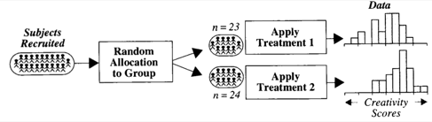

**Observational Study** Cannot draw causal inferences (due to **Confounding**)

Not always the goal (ex: predict whether or not an email is spam [predictive model])

Good when randomization may not be ethical (ex: cancer drug/placebo)

Suggest a direction for future research

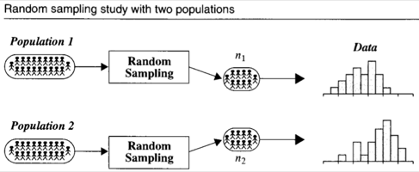

**Confounding Variable** Something related to both group membership and the outcome

**Inference**

**Causal** The treatment caused the effect

**Population** The result can be applied to a larger population than the subjects examined

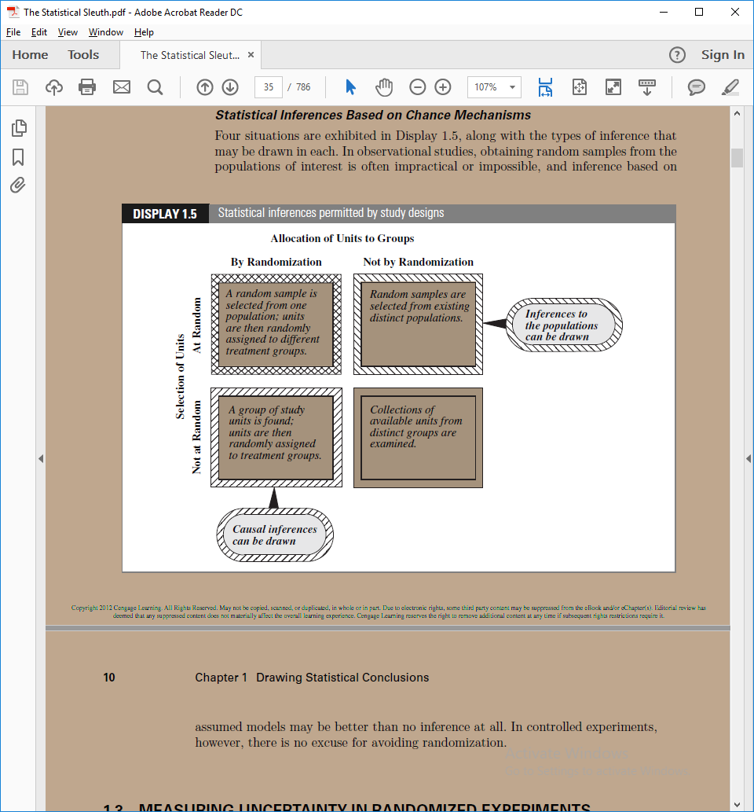

**Random Sample** Experimental units selected via a “chance mechanism” from a well-defined population

**Simple random sample**

Every subset of size n is equally likely

**Additive Treatment Effect** Y* = Y + 𝛿

**Systematic Random Sampling** ex: list of 20,000 pick one at random (a) from 1-200, then pick every 200th + a

**Random Cluster Sampling** ex: put list into blocks of size A, randomly pick a block

**Variable Probability Sampling** Allow some to have higher probabilities to being sampled

**Permutation Test** A test to see if some “treatment” had an effect (based on the difference of means).

A test for the difference in sample means.

**Method**

Get and save the difference of means.

(A)Randomly reallocate the data to the two groups and calculate the difference of means. If it is greater than the saved difference, increment the counter. Repeat (A) some number of times (ex: 10,000).

p-value = counter/number-of-permutations.

If p is small, there is evidence that the “treatment” had an effect.

If p is large, this provides no evidence that the “treatment” had an effect.

**UNIT 2**

**Central Limit Theorem** If $Y_{1}, Y_{2},…,Y_{n}$ represent the $n$ data points in a sample, then:

1. “approximately equals”

2. is “approximately distributed” normal if *n* is large.

3. Variance $(\overline{Y})=\frac{σ^{2}}{n}$

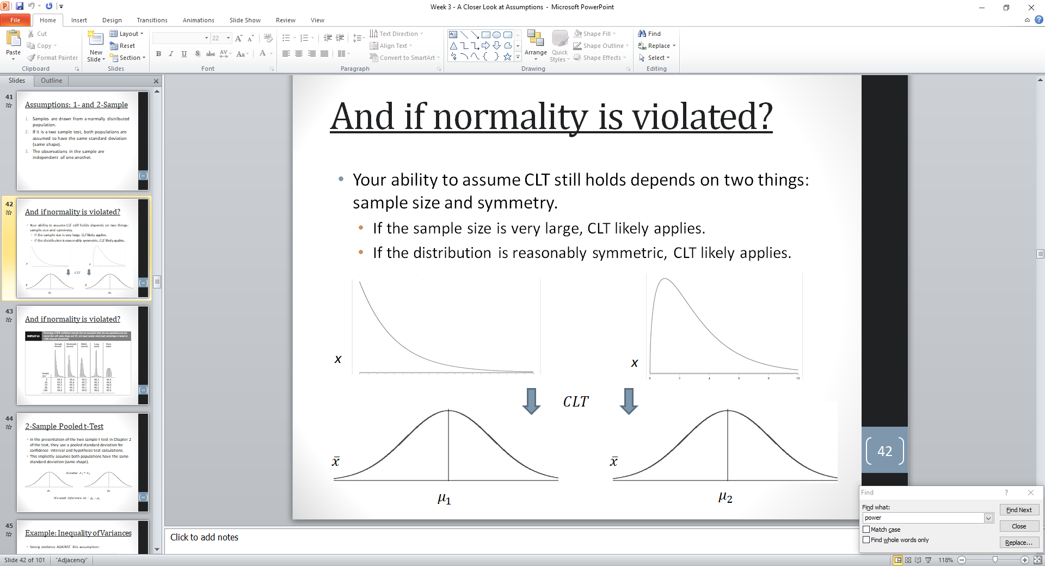

**T-Distribution**

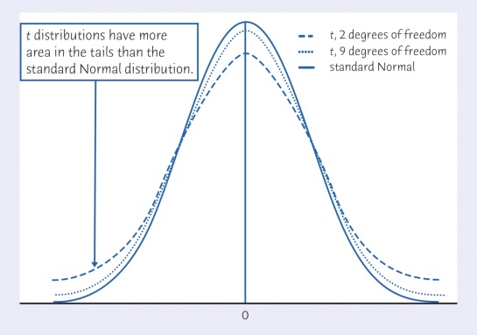

**Confidence Interval** ( $\overline{x}$- E < µ < $\overline{x}$ + E ) == ( $\overline{x}$– E, $\overline{x}$ + E ) E is the **error**

**6 Step Hypothesis Test**

Alternative hypothesis is what you want to prove

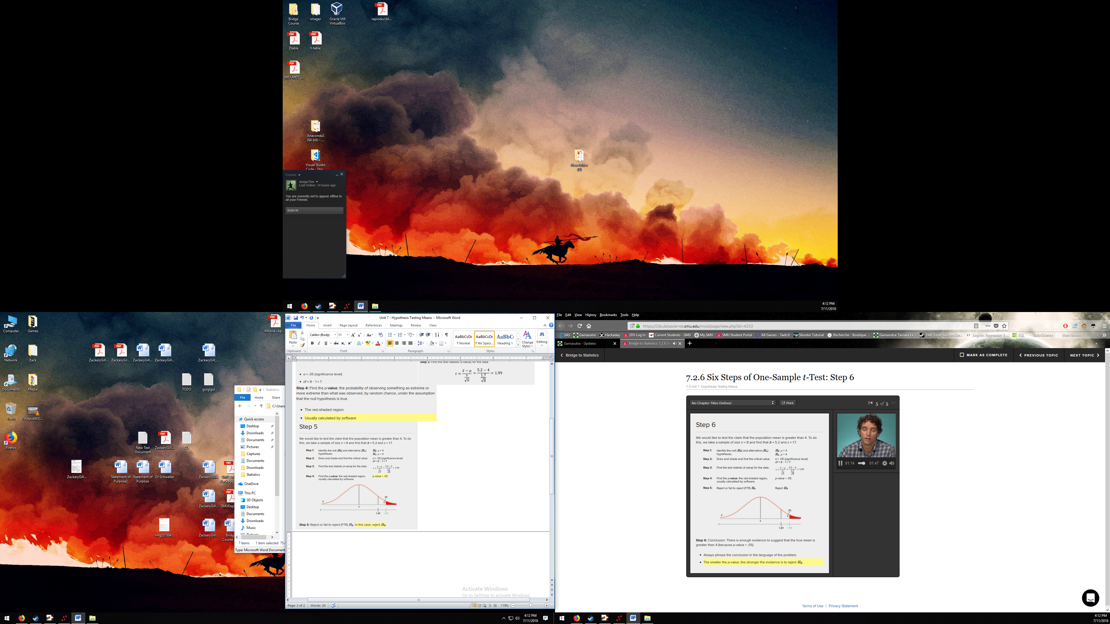

**Standard Error Estimate $s_{p}=\sqrt{\frac{\left(n_{1}-1\right)s_{1}^{2}+\left(n_{2}-1\right)s_{2}^{2}}{n_{1}+n_{2}-2}}$** **Pooled standard deviation**

**Power** Likelihood of correctly rejecting the null hypothesis = 1 – $β$

Power increases when

Sample size increases

Standard Deviation/Standard Error decreases

Effect size increases



**Type I error Type II Error** See chart of **Power**

**Type I error (Type 1) (α)** Rejecting Ho when Ho should not be rejected

**Type II error (Type 2) ($β$)** Not rejecting Ho when Ho should be rejected

**T-Test**

Not robust to long tails/outliers

Use t (instead of z) if $σ$ is unknown

If the standard deviations are different and the sample sizes are different, then the *t*-tools are not valid

**Paired – (see Paired t-test)**

**Pooled t-test**

**Assumptions**

Normally Distributed

Equal Variance

Independent

**1 and 2 sample assumptions**

Drawn from a normally distributed population

For two sample, both have same standard deviation (shape)

Observations are independent of one another

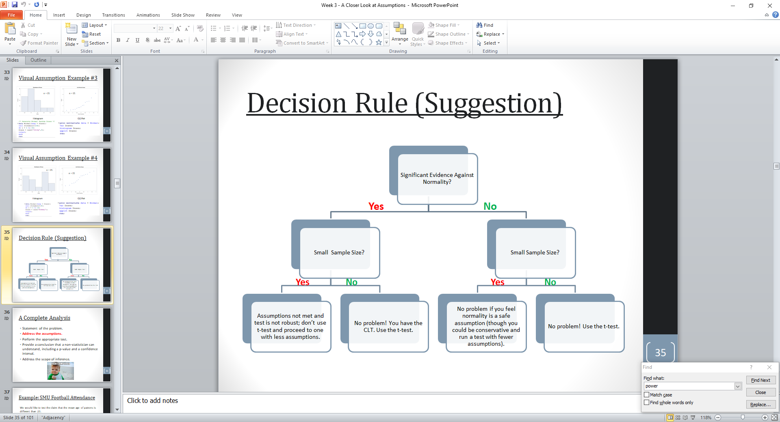

**Degrees of Freedom** Use for calculating the t-crit value

df = n-1, or df = $\sum{n}$– count(n)

**Normal Distribution**



**p-value** The probability of observing something as extreme of more extreme than what was observed, by random chance, under the assumption that the null hypothesis is true.

Effect Size / Cohen’s D

**UNIT 3**

**Independent** Observations are **independent** if knowledge of the value of one observation reveals nothing about values of other observations.

**Independence** must be built into experimental design.

**Dependence (Lack of Independence)**

**Cluster Effect** Occurs when the data have been collected in subgroups. (ex: mice from same litter)

**Serial Effect** Observations close together in time tend to be more similar than observations far apart in time.

**Spatial Correlation** Measurements are taken at locations close together tend to be more similar than ones taken at different locations.

**Transformations**

**Log** Typically log base e: $\log_{e}{x}$ Helps fix normality

**Square root $\sqrt{x}$**

**Reciprocal $\frac{1}{x}$**

**Arcsine square root $\sin^{-1}{x}$**

**Logit $\log_{e}{\frac{x}{1-x}}$**

**Dealing with outliers** Might want to use a **Transformation**

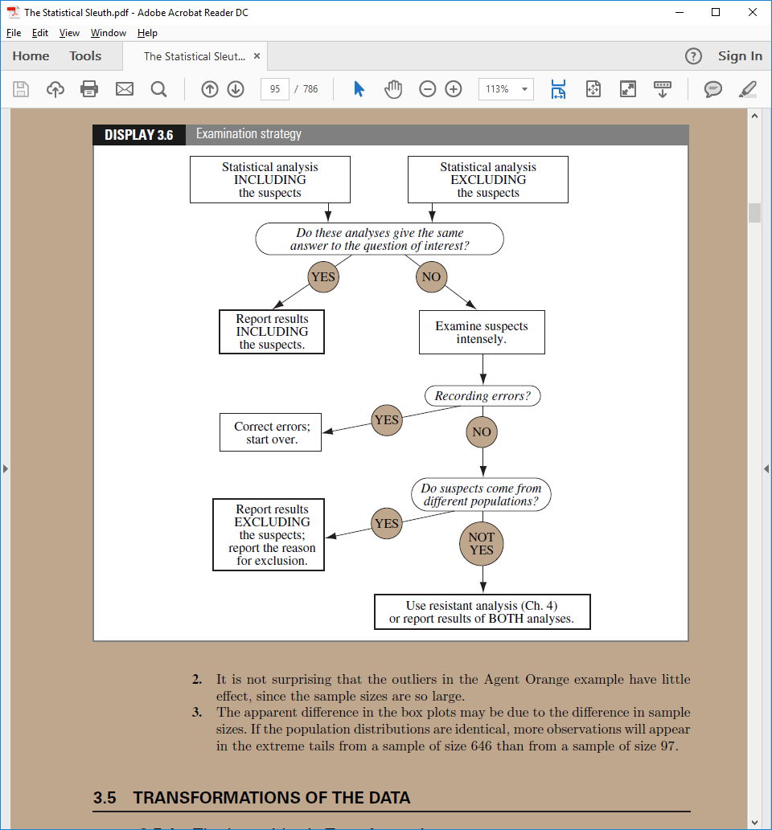

**Normal Quantile (QQ) plot** When the points are in a ${45}^{o}$ angle the data is normally distributed

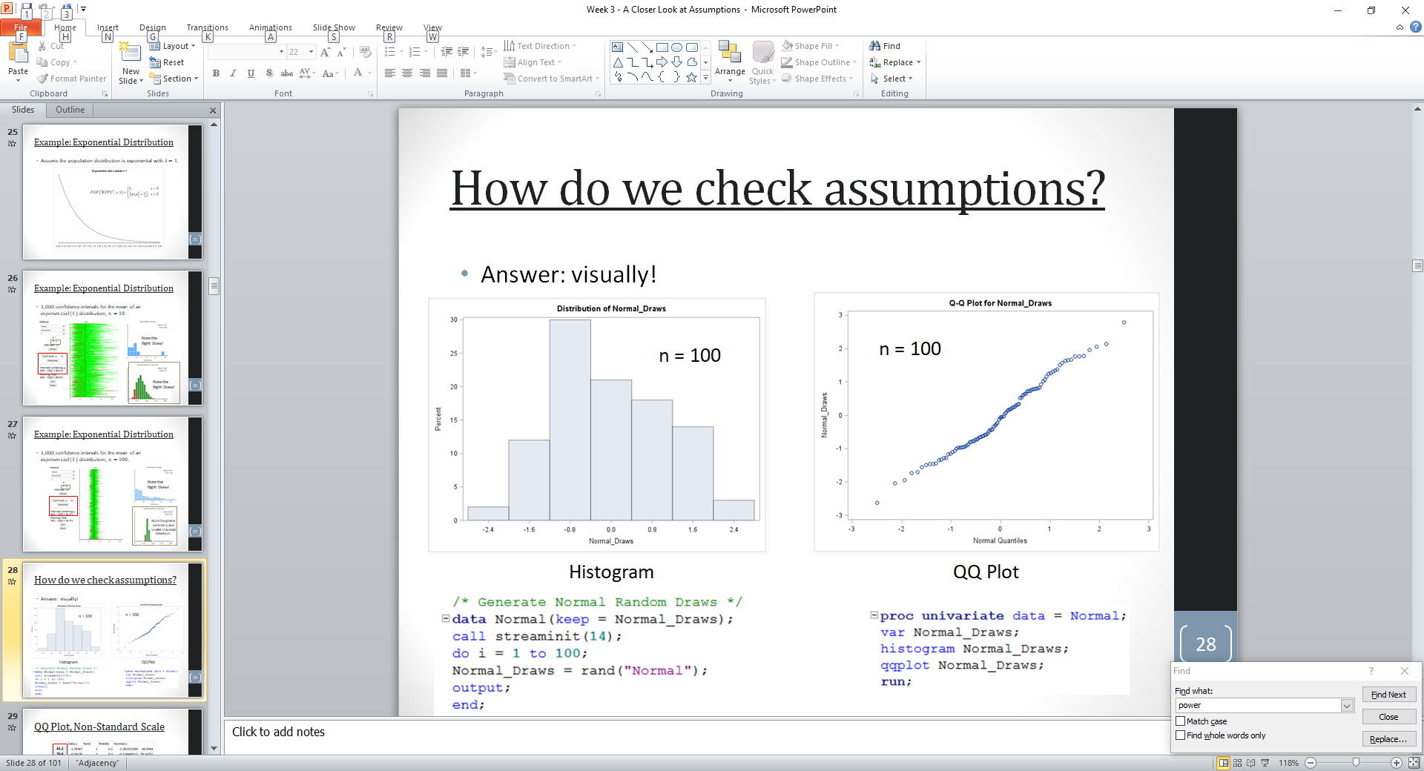

**Unit 4**

**Non-parametric test (or distribution-free)**

Doesn’t depend on underlying assumptions (pretty much)

Performs somewhat worse than parametric methods if the assumptions are approximately correct

**Rank-Sum test (Mann-Whitney test, Wilcoxon test [different from Wilcoxon signed-rank test])**

Resistant to outliers

Nearly as good as a **t-test** when both populations are normal

Considerably better than **t-test** when there are extreme outliers

Works well with **ordinal** data (as opposed to interval data).

Works with censored data

**Assumptions**

All observations are independent

The two distributions are the same (like both are normally distributed, or some other shape)

The Y values are ordinal (ex: survey questions [rate it 1-5])

**Hodges-Lehman confidence interval**

**Continuity correction**

For the **rank-sum test** (maybe others?)

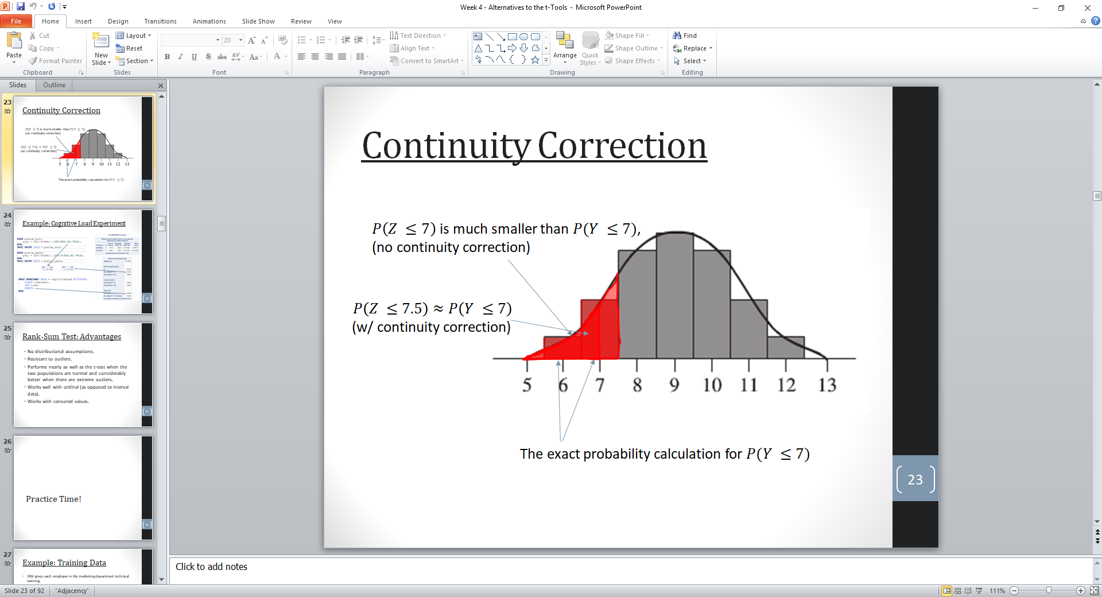

**Welch t-test**

When calculating df, always round up

Similar to **pooled t-test**, without the assumption of equal standard deviations

[in SAS corresponds to “Satterthwaite”]

**Assumptions**

Normally Distributed

Independence

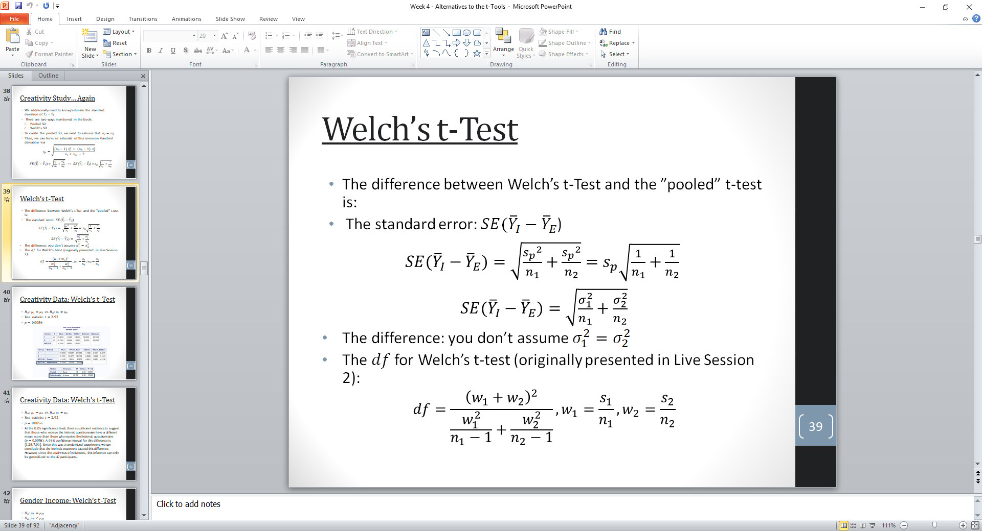

**Paired t-test (matched pairs/dependent)**

**Assumptions**

**Data is either**

From one sample that has been tested twice (example pre- and post-test /repeated measures).

From a group of subjects that are thought to be similar and can thus be matched or paired (example from same family, or twins).

Normally distributed

Independent between observations

Identical Variances

**Sign test**

Slide 65

**Assumptions**

Subjects are independent

Subjects are a random sample from a fixed population

**Signed Rank Test (its Wilcoxon’s)**

Retains more information than **sign test**

For paired data

Nonparametric alternative to the 2-sample **t-test**

Not good when there are lots of ties (use **permutation/randomization** in that scenario)

**Assumptions**

Subjects are independent

Subjects are a random sample from a fixed population

The differences are symmetric (not necessarily normal)

**Test Selection**

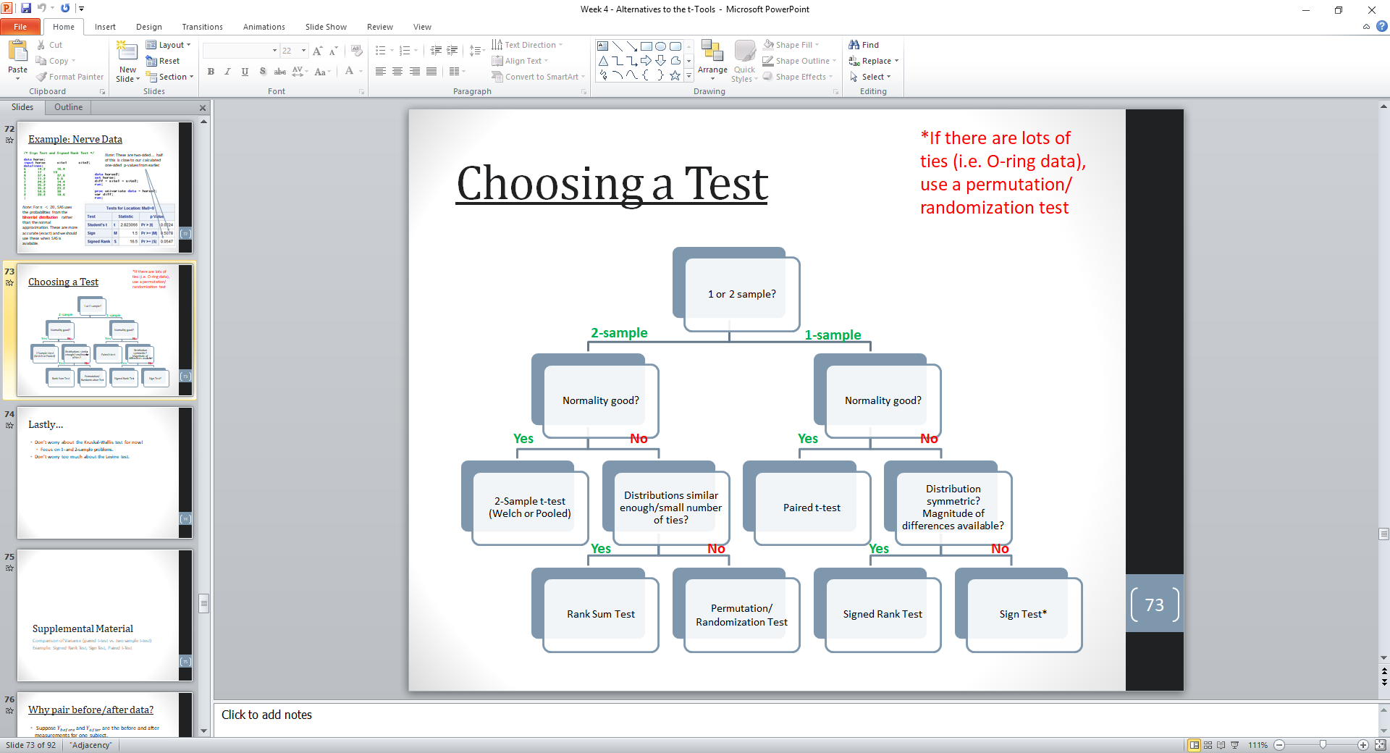

*If there are lots of ties use a permutation/randomization test

**Paired Data** options

1-sample **t-test**

**Wilcoxon Signed Rank Test**

**Sign Test**

Satterthwaite’s approximation

Equal spread model

Survey sampling

Simple random sampling

Stratified sampling

Multistage sampling

Cluster sampling

**Unit 5**

**Complete Analysis (state problem, assumptions, ~6 step [crit, pval…], don’t/do reject Ho, conclusion…)**

Statement of the problem

Address the assumptions

Perform the test

Provide a conclusion that a non-statistician can understand, including a p-value and confidence interval and what test was used.

Address the scope of inference

**ANOVA (analysis of variance F-test)**

This is a test about means

Constructing a BYOA table or Extra SS approach

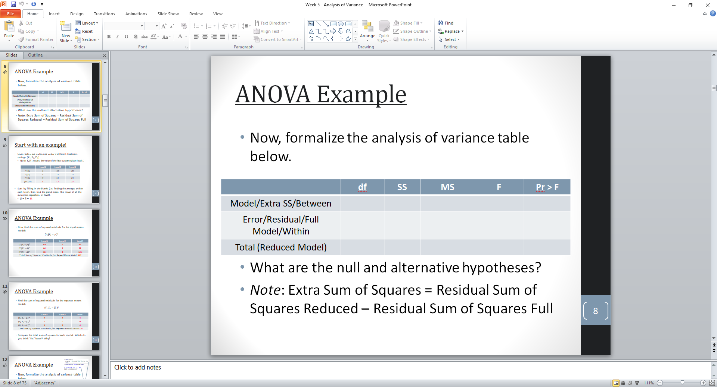 Ex: 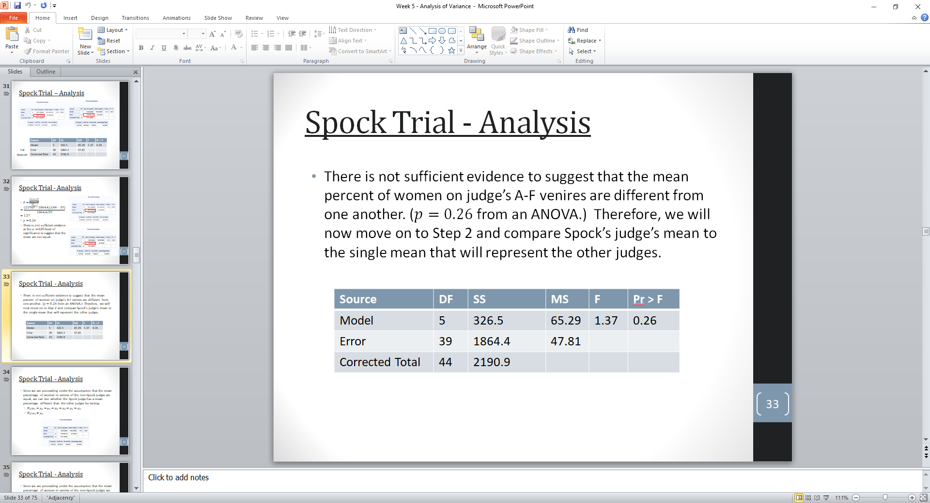

Six Step: Hypothesis, F-value, p-value, reject/don’t, conclusion

**Assumptions**

Normally Distributed

Equal Standard Deviations/Variance (super dooper important)

Independent within each sample, independent from other samples

**BYOA (Build your own ANOVA) WEEK 5 slide 29**

**F Distribution**

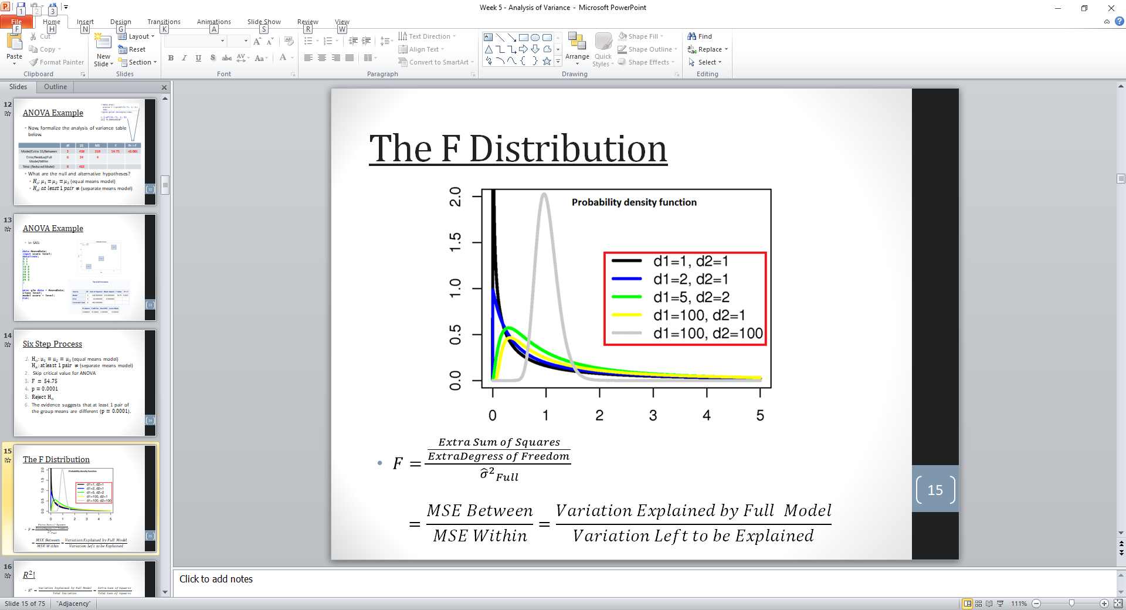

**Kruskal-Wallis ANOVA**

nonparametric

Uses chi squared distribution ($χ^{2}$)

Is talking about medians, not means

Is a rank based test

**Assumptions**

Experimental units are randomly selected from *k* populations (or have been randomly assigned to the treatments)

If there are differences, observations from at least one treatment will tend to be larger than observations from at least one other treatment.

**Levene’s Test**

Encourages you to “accept” the null hypothesis (*BAD*) in order to proceed to **pooled t-test**

Gives evidence of equal SD

**Assumptions**

Not robust against departures from normality

**Welch’s ANOVA**

Analogous to Welch’s/Satterthwaite’s two sample t-test

**Assumptions**

Normally Distributed

Independence

**Brown Forsythe (ANOVA?)**

Sees if the variances are different

Random Effects Models

Separate means model

ANOVA Full/Reduced/Others Equal model

**Writing Up Results**

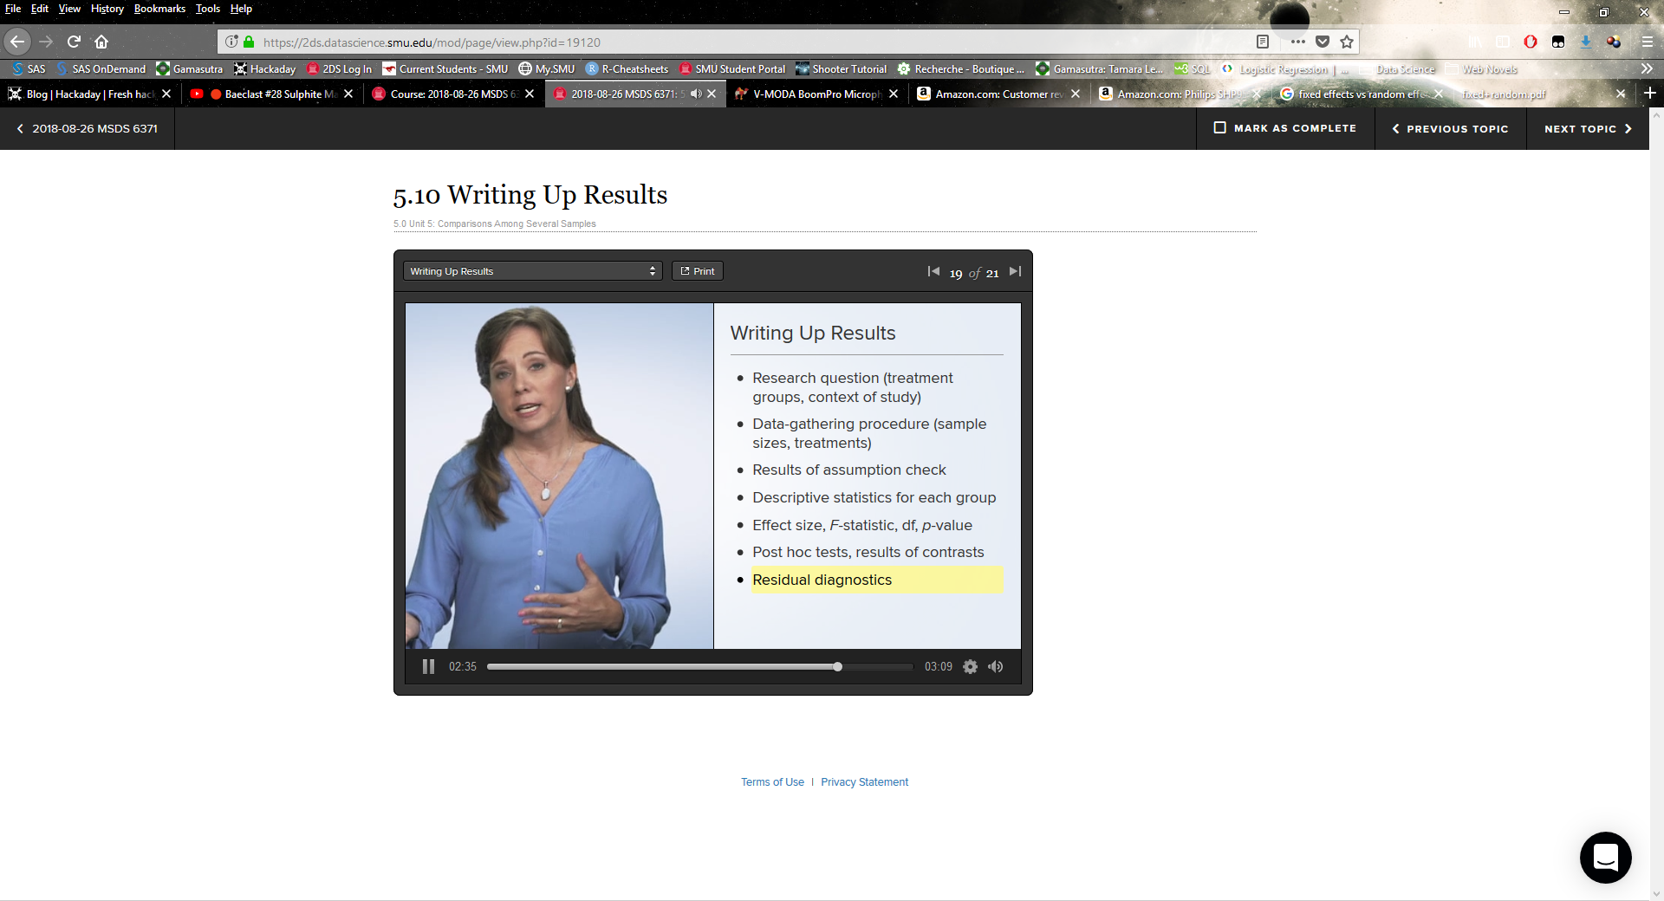

**Unit 6**

**Linear combinations & contrasts**

Compares some group(s) against another group(s)

Uses all groups to increase _______ (?)

**Planned and Post-Hoc Tests**

A planned test is one in which you know the comparisons (tests) you want to make before you look at the data

If you have $k$ **planned** comparisons then you need to correct for **just those $k$** comparisons

When planned comparisons are not available, **post-hoc** tests are conducted. In this case, we need to **correct for all possible comparisons between the $g$ groups.** k = $\frac{g(g-1)}{2}$

**Post-Hoc** Are appropriate when:

The researcher wants to examine all possible comparisons among pairs of group means (or a large number of comparisons).

Predictions about which groups will differ are not made prior to setting up the analysis.

**Bonferroni**

A test for all pairwise difference in means (multiple comparisons)

Very conservative, the intervals will be much wider than the nominal level.

Tends to not reject as often as it should.

Better than Tukey when Tukey’s assumptions are violated

**Assumptions**

No distributional assumptions (aka doesn’t have to be normally distributed)

Equal Variance

**Tukey-Kramer/Tukey’s HSD**

A test for all pairwise difference in means

Tukey’s HSD is when you have equal sample sizes, Tukey-Kramer Adjustment does not assume equal sample sizes

Better than Bonferroni with respect to **Type 1** error, but not robust to its assumptions

**Assumptions**

Normal distribution

Equal Spreads (variance)

Equal group sample sizes

**Dunnett**

Test for all pairwise difference from control

**Assumptions**

Normally Distributed

Equal Variance

Independence?

**Choosing a Multiple Comparison Model**

**Dunnett:** When you are comparing a control to several treatment

**Tukey-Kramer (Tukey’s HSD)** isbest when you are interested in all pairwise comparisons of means, but does assume normality and equal variances.

**Bonferonni** is a general purpose correction that can be done outside the realm of ANOVA, but is generally very conservative.

**Scheffe** is another very conservative method that is appropriate when you are interested in potential unplanned contrasts involving the means (i.e. more than just pairwise comparisons).

**REGWQ** (in SAS) is the best option when you do not need confidence intervals and the design is balanced.

**REGQQ**

**Assumptions**

Equal Variance

Equal Sample sizes in each group

**Scheffe’s Method**

A test of all possible differences

**Assumptions**

Equal Variance

**LSD**

**Assumptions**

Equal Variance

Brown-Forsythe

**Hypothesis testing Fallacies**

**False Causality**

Incorrectly interpreting statistical significance from an observational study as evidence of causation.

To avoid this fallacy, use the word association to indicate a relationship that is not necessarily a causal one.

**Accepting the Null**

Incorrectly interpreting a lack of statistical evidence that a null hypothesis is false (i.e. a large p-value) as statistical evidence that the null hypothesis is true.

Example: “The study provides evidence that there is no evidence.”

Instead, say “There is no evidence from this study of a difference.”

Reporting a confidence interval helps reinforce that there are many plausible values.

**Confusing statistical and Practical significance**

Interpreting a “statistically significant” effect as a practically important one, when it may or may not be.

Example: taking a weight loss pill for 7 months results in a statistically significant decrease in weight, estimated to be 0.12 pounds.

Reporting a confidence interval can help the reader evaluate the practical significance.

**Data Dredging**

Easily the worst and most common fallacy.

Incorrectly drawing conclusions from an unadjusted p-value that emerged from a process of sifting through many possible p-values.

There is a well known publication bias that exists due to journals being more inclined to accept papers with statistically significant findings.

**Good statistics from bad data**

Incorrectly accepting conclusions based on sound statistical technique when there are problems with data collection, such as biased sampling or data contamination.

This is a hard problem to deal with, especially if you are asked to do secondary analyses.

The only solution is to critically evaluate the potential biases from non-randomly selected samples.

**Statistical Tests**

**Permutation Test**

**T-Test**

**1 Sample**

**2 Sample**

**Pooled**

**Paired**

**Rank-Sum test (Mann-Whitney test, Wilcoxon test [different from Wilcoxon signed-rank test])**

**Welch t-test**

**Sign test**

**Signed Rank Test (its Wilcoxon’s)**

**ANOVA (analysis of variance F-test)**

**Kruskal-Wallis ANOVA**

**Levene’s Test**

**Welch’s ANOVA**

**Brown Forsythe (ANOVA?)**

**Linear combinations & contrasts**

**Bonferroni**

**Tukey-Kramer/Tukey’s HSD**

**Dunnett**

**Scheffe**

**REGWQ**

**LSD**

Brown-Forsythe

**What test to Use**



*If there are lots of ties use a permutation/randomization test

**Paired Data** options

1-sample **t-test**

**Wilcoxon Signed Rank Test**

**Sign Test**

**Choosing a Multiple Comparison Model**

**Dunnett:** When you are comparing a control to several treatment

**Tukey-Kramer (Tukey’s HSD)** isbest when you are interested in all pairwise comparisons of means, but does assume normality and equal variances.

**Bonferonni** is a general purpose correction that can be done outside the realm of ANOVA, but is generally very conservative.

**Scheffe** is another very conservative method that is appropriate when you are interested in potential unplanned contrasts involving the means (i.e. more than just pairwise comparisons).

**REGWQ** (in SAS) is the best option when you do not need confidence intervals and the design is balanced.

**Phrasing an Answer**

**1 sample t-test**

On the basis of this test, there is enough evidence to reject the claim that the mean weight of bumblebee bats is equal to 1.8g (p=0.0342 from a two-sided t-test). A 95% confidence interval is [1.5065, 1.7869] grams, with a point estimate of 1.6467 g.

There is not sufficient evidence to suggest that the mean score of those who were fired is greater than (or different from) the mean age of those who were not fired (p=0.133,p=0.269 for a one-sided and two-sided test, respectively).

On the basis of this test, there is not enough evidence to suggest that the mean ages of the fired and not fired groups are different. In other words, there is not enough evidence to suggest that there is discrimination based on age (p=0.2771 from a two-sample t-test, p=0.1385 from a one-sample t-test). A 95% confidence interval for this difference is [-1.60,5.44] years.

**Explaining an interval that includes zero**

Because 0 is included in the interval and is thus a probable value, we don’t have enough evidence to conclude a difference exists.

**2 sample t-test**

Based on this test, there is not enough evidence to suggest that the mean amount of pocket cash of the SMU students is different than that of the students from Seattle U (p=0.1732 from a two-sided t-test). A 95% confidence interval for this difference is [-$53, $282].

**2 sample t-test with log transformed data**

There is overwhelming evidence at the alpha = 0.05 level of significance (p < 0.0001) that the median income in 2005 for people with 16 years of education is 1.77 times as large as the median income for those in the study that had only 12 years of education. A 90% confidence interval for this factor is [e-.6553, e-.4844]= [1.62, 1.93].

**Rank sum test**

There is sufficient evidence to suggest that the distribution of the percent seedlings lost in the logged plots is more than that of the unlogged plots (p=0.0075 from a one-sided rank sum test). A 95% confidence interval for the increase in median percent seedlings lost in logged plots is [10.8,65.1]. Note that a 90% confidence interval [18.9,62.0] may be more appropriate for a one-sided test with significance level α=0.05, so that the results of thy hypothesis test and confidence intervals match up.

There is sufficient evidence to suggest that the distribution of metabolic expenditure for the trauma group is different from that of the non-trauma group (p=0.0031 from a two-sided rank sum test). A 95% confidence interval for the difference in medians is [1.9,16.7] kcal/kg/day

**Wilcoxon Signed Rank Test**

There is evidence that the median difference in time to finish the puzzle was greater than 0 (p=0.0166 from a one-sided signed rank test).

**Permutation distribution for Rank sum Test**

The mean of the normal distribution here was 59 and the standard deviation was about 9.3. The mean of the normal approximation found through theory in the prior problem was 56 with a standard deviation of about 8.6. The first one was found by fitting the normal curve to the permutation test while the second one came from theory. We don’t expect them to be identical, although we do expect them to be close.

**Log transformed ANOVA**

There is strong evidence to suggest that at least one of the median incomes (median, not mean, because we used a log transform) for a particular education level is different from the others (p<0.0001 from a pure ANOVA).

**Phrasing: Inference**

Since this was a random sample of employees in Samoa, we can generalize the inference to all employed people in Samoa.

Since the subjects in this sample were not randomly sampled, the results only generalize to the subjects in the study (no need to discuss causal conclusions for a non-significant result).

These 30 students were not from a random sample; therefore, inference cannot be extended beyond the 30 subjects in the sample. Since we failed to reject Ho, there is no need to write up whether causal inference can be drawn.

This was an observational study, and thus we cannot confirm that the years of education caused the increase in income, only that they are associated with each other. There is little detail about the randomness of the sample, although it is doubtful that it was a random sample. We must limit the inference gained from this study to only the subjects of this sample.

The data are strictly observational, and thus only an association between the presence of trauma and metabolic expenditure can be drawn. It is unclear how the sample was taken; therefore, we will assume the patients were not selected at random and the inference here is limited to the 15 subjects in the survey.

**Phrasing: Assumptions**

**Normality:**

There is little if any evidence from the histograms and QQ plots of any departures from normality from these data. We will assume they do come from normal distributions.

There is significant evidence from the histograms and q-q plots of severe departures from normality for these data. We will assume they do not come from normal distributions.

While the q-q plots looks more normal, the normality of the original data is of little concern, given that the large sample size should ensure the sampling distribution of the means is normal (from the Central Limit Theorem CLT)

There is strong evidence that the incomes come from right skewed distributions. We have large enough sample size (n_12=1020, n_16=406) to ensure a t-test will be robust to this assumption in this case.

**Equal standard deviations:**

There is little evidence that the samples are pulled from distributions that have different standard deviations, thus we will assume that the standard deviations are equal.

There is significant evidence to suggest that the standard deviations of these distributions are different.

There is visual evidence of different standard deviations. Because the sample sizes are significantly different, the test is not robust to this assumption.

**Independence:**

We will assume that the observations are independent both between and within groups.

**Ordinal:**

The data are ordinal as they are percentages of seedlings.

**Phrasing: State the Problem**

We wish to test the claim that the mean age of the fired group is different than the mean age of the not fired group for this population of American Samoa working citizens. In other words, we are testing the claim that age discrimination exists for this population

Test the claim that the mean amount of pocket cash in SMU’s and Seattle U’s students’ pockets is different.

Test the claim that the distribution of incomes for those with 16 years of education exceeds the distribution for those with 12 years of education.

Test the EPA’s assertion (and thus the opposite of the logging industry’s assertion) that logging actually increases the percentage of seedlings lost from 2004 to 2005.

Test whether there is a difference in income between those with a bachelor’s degree and those with more than a bachelor’s degree.

**Code for each Test**

**LOG**

#Calculates the log of the data and stores it in a new column

df$log <- log(df$data)

#The multiplicative effect

1/exp(result) #OR

exp(result)

**SHADING**

#RUN ShadeFunction.r first

#both, left, right, t_calc is the calculated test statistic

#shade(df, alpha, h0 = 0, sides='both', t_calc=NULL)

shade(49, 0.05, 0, t_calc=1.1)

**DRAWING – ONE QQ Plot**

par(mfrow=c(2,2)) #for showing 2 rows and 2 columns of plots

qqnorm(weather.final$happy[weather.final$weather=="Sunny"], main='Sunny')

qqline(weather.final$happy[weather.final$weather=="Sunny"])

**DRAWING – ALL QQ Plot**

library(ggplot2)

ggplot(spock, aes(sample=Percent) ) + stat_qq() + facet_grid(~Judge)

**DRAWING – ONE Histogram**

par(mfrow=c(2,2)) #for showing 2 rows and 2 columns of plots

hist(weather.final$happy[weather.final$weather=="Sunny"], xlab='Happiness', main='Sunny')

**DRAWING – ALL Histograms**

library(ggplot2)

ggplot(spock, aes(x=Percent) ) + geom_histogram() + facet_grid(~Judge)

**DRAWING – ALL Boxplots**

boxplot(happy ~ weather, data=weather.final, horizontal=T, main='Boxplots of Happiness Score, by Weather')

**Permutation Test**

##Read in the data for Fired and Not Fired

f <- c(34, 37, 37, 38, 41, 42, 43, 44, 44, 45, 45, 45, 46, 48, 49, 53, 53, 54, 54, 55, 56)

nf <- c(27, 33, 36, 37, 38, 38, 39, 42, 42, 43, 43, 44, 44, 44, 45, 45, 45, 45, 46, 46, 47, 47, 48, 48, 49, 49, 51, 51, 52, 54)

##Fill two empty vectors with 1/0 corresponding to if Fired/Not Fired

flen <- rep( 1, length(f) )

nflen <- rep( 0, length(nf) )

##Creates the data frame 'employmentstatus' with columns: 'age' 'isfired'

employmentstatus <- data.frame( age=c(f, nf), isfired=c(flen, nflen) )

##We will use the t.test to get the mean

t.test( employmentstatus$age ~ employmentstatus$isfired )

##Define how many permutations you want

number_of_permutations <- 1000

##Create an empty vector to store the permuted averages

xbarholder <- numeric(0)

##Initialize a counter to see how many differences exceed the observed differences

counter <- 0

##Define the value of the observed difference

observed_diff <- mean( subset(employmentstatus, isfired == 1)$age ) - mean( subset(employmentstatus, isfired == 0)$age )

##Create a 'for' loop that carries out our simulation

for(i in 1:number_of_permutations)

{

##Randomly sample all 30 employmentstatus money without replacement, which is equivalent to randomly reordering them

scramble <- sample( employmentstatus$age, 51 )

##Assign the randomly reordered money to fauxf and fauxnf

fauxf <- scramble[1:21]

fauxnf <- scramble[22:51]

##Calculate the new observed difference in means

diff <- mean( fauxf ) - mean( fauxnf )

##Store this difference in our previously empty created vector

xbarholder[i] <- diff

##Decide whether our permuted difference is more extreme than the actual observed difference; if so, bump up the counter

if( abs(diff) > observed_diff )

counter <- counter + 1

}

##Create a histogram of all observed differences

hist( xbarholder )

##Calculate our p-value

pvalue <- counter / number_of_permutations

##View only the permuted differences that were more extreme than the observed

xbarholder[ which(abs(xbarholder) > observed_diff) ]

**Power – Unit 2**

proc power;

twosamplemeans

stddev = 6.1519

power = 0.6 0.7 0.8

ntotal = .

meandiff = 0.2;

plot x = effect min = 0.5 max = 2;

run;

*Using your last plot, estimate the savings in sample size from a test aimed at detecting an effect size of 0.8 with a power of 80% versus a power of 60%.;

Proc power;

twosamplemeans

stddev = 6.1519

power = 0.6 0.8

ntotal = .

meandiff = 0.8;

run;

**T-Test 1 Sample**

smu <- c(25, 19, 37, 29, 40, 28, 31)

##Use this command to find the critical value for an alpha=0.05 test with 6 degrees of freedom

qt(0.975, 6, lower.tail=T)

##This command gives both a t-test and a confidence interval

t.test(smu, mu=21, alternative='two.sided', conf.level=0.95)

**T-Test 2 Sample**

creativity <- case0101

##Use this command to find the critical value for an alpha=0.05 test with 45 degrees of freedom

qt(0.975, 45, lower.tail=T)

t.test(creativity$Score ~ creativity$Treatment, alternative='two.sided', conf.level=0.95, mu=0)

**T-Test Pooled**

creativity <- case0101

##Use this command to find the critical value for an alpha=0.05 test with 45 degrees of freedom

qt(0.975, 45, lower.tail=T)

t.test(creativity$Score ~ creativity$Treatment, alternative='two.sided', conf.level=0.95, mu=0, var.equal=T)

**T-Test Paired**

creativity <- case0101

##Use this command to find the critical value for an alpha=0.05 test with 45 degrees of freedom

qt(0.975, 45, lower.tail=T)

t.test(creativity$Score ~ creativity$Treatment, alternative='two.sided', conf.level=0.95, paired=T)

**Signed Rank Test (its Wilcoxon’s)**

wilcox.test(side_effect$Marijuana, side_effect$Placebo, paired=T, alternative='less', conf.int=T)

**Rank-Sum test (Mann-Whitney test, Wilcoxon test [different from Wilcoxon signed-rank test])**

##Exact

wilcox.test(scores ~ method, data=teaching, alternatve='greater')

##Normal Approximation

wilcox.test(scores ~ method, data=teaching, alternatve='greater', exact=F)

##Exact w/ confidence interval

wilcox.test(scores ~ method, data=teaching, alternatve='greater', conf.int=T, conf.level=0.9)

**Welch t-test in R DIFFERENT FROM t.test?**

**Sign test**

#18 participants, 5 like new remaining like old. Ho both are equal.

binom.test(5, 18) # alternative='greater')

**ANOVA (analysis of variance F-test)**

case0601 <- read.csv("ex0525.csv")

aovHandi <- aov(Salary2005 ~ Educ, data = case0601)

summary(aovHandi)

**Kruskal-Wallis ANOVA**

zombie <- read.csv("zombie.csv")

handi.kruskal <- kruskal.test(Blood_Virus ~ Site, zombie)

**Levene’s Test (Overall ANOVA with Levene's test)**

proc glm data=handicap;

class handicap;

model score = handicap;

means handicap / HOVTEST=BF;

run;

arch <- read.csv("Archeology ANOVA Example.csv")

leveneTest(arch$Depth, as.factor(arch$Site))

**Welch’s ANOVA**

##Welch's ANOVA Example

oneway.test(Percent ~ Judge, spock, var.equal=F)

**Brown Forsythe (ANOVA?)**

**Linear combinations & contrasts**

spock <- case0502

mean.spock <- with(spock, tapply(Percent, Judge, mean))

var.spock <- with(spock, tapply(Percent, Judge, var))

n.spock <- with(spock, tapply(Percent, Judge, length))

s.pooled <- sqrt(sum(var.spock*(n.spock-1))/sum(n.spock-1))

##Option 2: define contrast on all groups, then calculate

contr <- c(6, -1, -1, -1, -1, -1, -1)/6

g <- sum(contr * mean.spock)

se.g <- s.pooled*sqrt(sum(contr^2/n.spock))

t.39 <- qt(0.95, 39)

##Calculation of CI

g + c(-1,1) * t.39 * se.g

**Bonferroni**

case0601 <- read.csv("ex0525.csv")

aovHandi <- aov(Salary2005 ~ Educ, data = case0601)

handi.bonf <- LSD.test(aovHandi, 'Handicap', p.adj='bonferroni')

**Tukey’s HSD**

library(agricolae)

library(multcomp)

case0601 <- read.csv("ex0525.csv")

aovHandi <- aov(Salary2005 ~ Educ, data = case0601)

handi.tukey <- HSD.test(aovHandi, 'Educ', group=FALSE)

#OR can use TukeyHSD(aovHandi)

**Tukey-Kramer**

library(agricolae)

library(multcomp)

case0601 <- read.csv("ex0525.csv")

aovHandi <- aov(Salary2005 ~ Educ, data = case0601)

gout <- glht(aovHandi, mcp(Educ = 'Tukey'))

confint(gout)

summary(gout)

**Dunnett**

library(agricolae)

library(multcomp)

zombie <- read.csv("zombie.csv")

aovHandi <- aov(Blood_Virus ~ Site, data = zombie)

handi.count <- table(zombie$Site) #Print handi.count to see which number to choose for base in the next line

base_12 <- contrMat(handi.count, base=3, type="Dunnett") #Changes the one that is compared against

handi.dunnett <- glht(aovHandi, linfct=mcp(Site = base_12)) #Does Dunnett's test

summary(handi.dunnett) #Gives p values and difference between means

confint(handi.dunnett) #Give the confidence intervals

**Scheffe**

case0601 <- read.csv("ex0525.csv")

aovHandi <- aov(Score ~ Handicap, data = case0601)

handi.scheffe <- scheffe.test(aovHandi, 'Handicap')

**LSD**

case0601 <- read.csv("ex0525.csv")

aovHandi <- aov(Score ~ Handicap, data = case0601)

handi.lsd <- LSD.test(aovHandi, 'Handicap', p.adj='none')

**REGWQ**